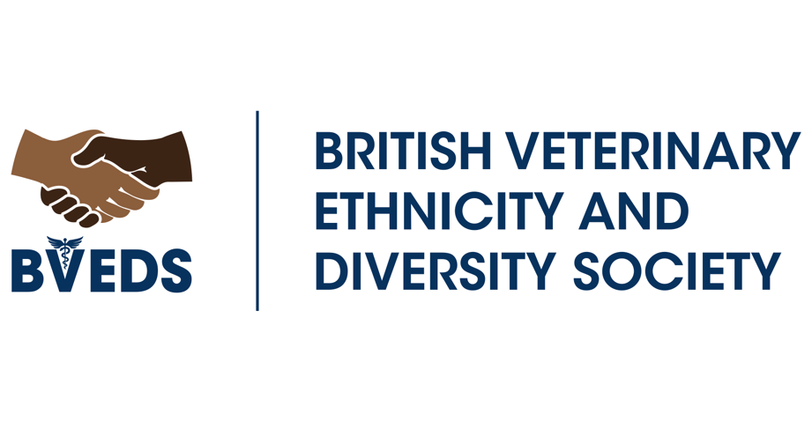

British Veterinary Ethnicity & Diversity Society
Trustees’ Annual Report and Financial Statement
Period From 18-05-2023 to 18-05-2024

For the Year Ended 18th May 2024

The trustees have the pleasure of presenting their annual report, the financial statements, and the independent examiner’s report for the year ended 18th May 2024.

BVEDS2016@gmail.com

Reference and Administrative Information

Charity name: British Veterinary Ethnicity & Diversity Society (BVEDS)
Scottish Charity Number: SC050312
Charity Address: 31/6 Marchmont Crescent, Edinburgh, EH91HQ
Email address: bveds2016@gmail.com
Website www.bveds.com

Twitter: @bveds2016
Facebook: https://www.facebook.com/BritishVEDS/

Charity Trustees


- Charity Trustee Chair: Mandisa Greene

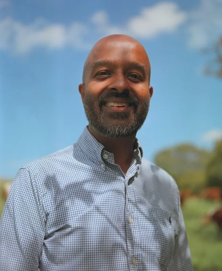
- Charity Trustee Treasurer: Navaratnam Partheeban


- Charity Trustee Secretary: Marissa Robson

No new trustees were appointed during the 2023-24 period.
BVEDS charity is made up of trustees and volunteers.
The charity has no paid employees.
Structure, governance and management
BVEDS is a registered Charity with OSCR - the Scottish Charity regulator. OSCR granted BVEDS charitable status on 22 July 2020. BVEDS is a charitable, unincorporated association. It is governed by its constitution, which was adopted on 20th May 2020.
Membership
BVEDS full membership is open to all those interested in equality and diversity in the veterinary, nursing, students and allied professions, regardless of race or ethnicity. Register as a full member here: bveds2016@gmail.com
Appointment of Trustees
Trustees are elected by Trustees at the Annual General Meeting, which is normally held in February. The trustees may co-opt further trustees if they consider doing so would be in the charity's interests. Under the constitution, there must be a minimum of three and not more than six elected trustees.
Trustee recruitment and appointment
BVEDS charity always seeks trustees from diverse backgrounds in veterinary nursing, veterinary medicine, students, and allied professions. We welcome you to get in touch if you are interested in applying for a Trustee position at bveds2016@gmail.com We are looking to appoint another 3 trustees in the coming years.
Management
The trustees are responsible for the strategic direction and governance of the charity, whilst day-to-day running tasks are also assisted and delegated to BVEDS volunteers.
The management committee currently consists of the charity’s trustees, who meet annually or as needed. Throughout the year, we hold meetings to discuss progress and development.

Objectives and activities

BVEDS charity objectives are:
- To promote the veterinary professions (veterinary nursing and veterinary medicine) to people of diverse racial, ethnic and economic backgrounds.
- To provide signposting, educational and policy guidance to veterinary organisations, allied professions and individuals wishing to address inequality in access to the veterinary professions.
- To create a collaborative network of individuals and organisations within the professions focusing on equality and diversity and tackling discrimination.
- To support individuals dealing with discrimination & inequity.
Achievements and performance
During the financial period 2023-2024 we have engaged in the following activities.
- BVEDS has been engaged in educational talks and conferences in the UK and internationally on the topic of equity, diversity & inclusion (EDI).
- BVEDS has continued to provide signposting, educational and policy guidance to veterinary organisations, allied professions and individuals wishing to address inequality in access to the veterinary professions.
- Supported individuals dealing with discrimination and allies, creating more inclusive workplaces.
- Assisted in supporting a collaborative EDI training organisation for the veterinary sector.
- Has received donations for the purpose of providing financial support for students in hardship and has created a procedure for awarding grants.

Financial review
Financial year:18-05-2023 to 18-05-2024
At the end of 2021-2022, BVEDS held £885 in its bank account.
At the end of 2022-2023, BVEDS held £2386 in its bank account.
At the end of the 2023-2024 period, the charity holds £2970 in its bank account.

Receipts
£656 was received by BVEDS charity in 2023-2024.
Our main funding source continues to be small donations from individuals and payment for providing educational anti-racism talks.
Receipts on the unrestricted fund were £656 (2022- 2023: £1001)
This was made up of:
- £500 as payment for an educational session for a corporate veterinary service provider.
- £156 as several small donations from individuals through Just Giving.

Payments
Payments from the unrestricted fund for the year were £72 for a conference banner.

Transfers
At the end of the year, £2000 was transferred from the unrestricted fund to the restricted ‘Pay it forward’ fund before the PIF fund opened in Nov 2024 for grant applications from final-year students in financial hardship.

Reserves Policy
The trustees’ policy is to maintain positive reserves of £200 in the unrestricted fund and no deficits.
Following the transfer of £2000 from the unrestricted to the restricted PIF fund at the end of the 2023-2024 period, £970 remained in the unrestricted fund for general use, which is within the target range.
Plans for Future Periods
The trustees intend to continue generating income through educational talks and donations. Next year, BVEDS intends to step up fundraising activities and apply for grants.

Statement of Receipts and Payments – For the Year Ended 18th May 2024.
Receipts | Note | Unrestricted  Funds | Restricted Funds | Total 2024 | Total 2023
Donations | 1 | 156 | - | 156 | 1,001
Receipts from other Charitable Activities |  | 500 | - | 500 | 500
 |  |  |  | 656 | 1,501

Payments
Cost of Charitable Activities | 2 | 72 |  | 72 | -
Total Payments |  |  |  | 72 | -

Surplus /(deficit) for the year |  | 584 | - | 584 | 1,501
Transfer between funds | 3 | (2,000) | 2,000 | - | -
Surplus /(deficit) for the year |  | (1,416) | 2,000 | 584 | 1,501

The Notes on page 9 form an integral part of these accounts

Statement of Balances – As at 18th May 2024
 | Unrestricted  Funds | Restricted  Funds | Total 2024 | Total 2023
Cash in current account 18/5/2023 | 2,386 | - | 2,386 | 885
Surplus /(deficit) for the year | (1,416) | 2,000 | 584 | 1,501
Cash in current account 18/5/2024 | 970 | 2,000 | 2,970 | 2,386

Notes to the Accounts – For the Year Ended 18th May 2024.
Basis of Accounting
These accounts have been prepared on the Receipts and Payments basis in accordance with the Charities and Trustee Investment (Scotland) Act 2005 and the Charities Accounts (Scotland) Regulations 2006 (as amended), ensuring transparency in our financial reporting.
Related Party Transactions
No remuneration was paid to the trustees or to any connected persons during the year (2022-23: Nil).
- Nature and purpose of funds
Unrestricted funds are those that may be used at the discretion of the trustees to further the objectives of the charity. The trustees maintain a single unrestricted fund for the day-to-day running of the charity.
Restricted funds may only be used for specific purposes. Restrictions arise when the donor specifies, or funds are raised for specific purposes. This year, a restricted ‘Pay it Forward” fund was created in advance of the PIF grant applications opening.

- Cost of Charitable Activities
£72 for a conference banner
- Transfers between funds
This year, £2000 was transferred from the unrestricted fund to the restricted ‘Pay it Forward” fund in advance of the PIF grant applications opening.

Declaration
Approved by the trustees on Feb 15th 2025, and signed on behalf of the charity trustees by:
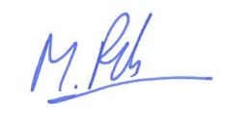

Marissa Robson
Charity Trustee Secretary
Preparation Date: Feb 15th 2025

